**PRAKTIKUM 6**

Nama : Ananta Satya Dhamma

NIM : 18090003

Kelas : 5C

1. Source Code

ModelUser.php => model

ModelBuku.php => model

v_bootstrap.php => view

1. Url

<http://localhost/Pustaka_booking_anan/Bootstrap>

1. Capture Output Program

**v_bootstrap.php**

( <http://localhost/Pustaka_booking_anan/Bootstrap> )

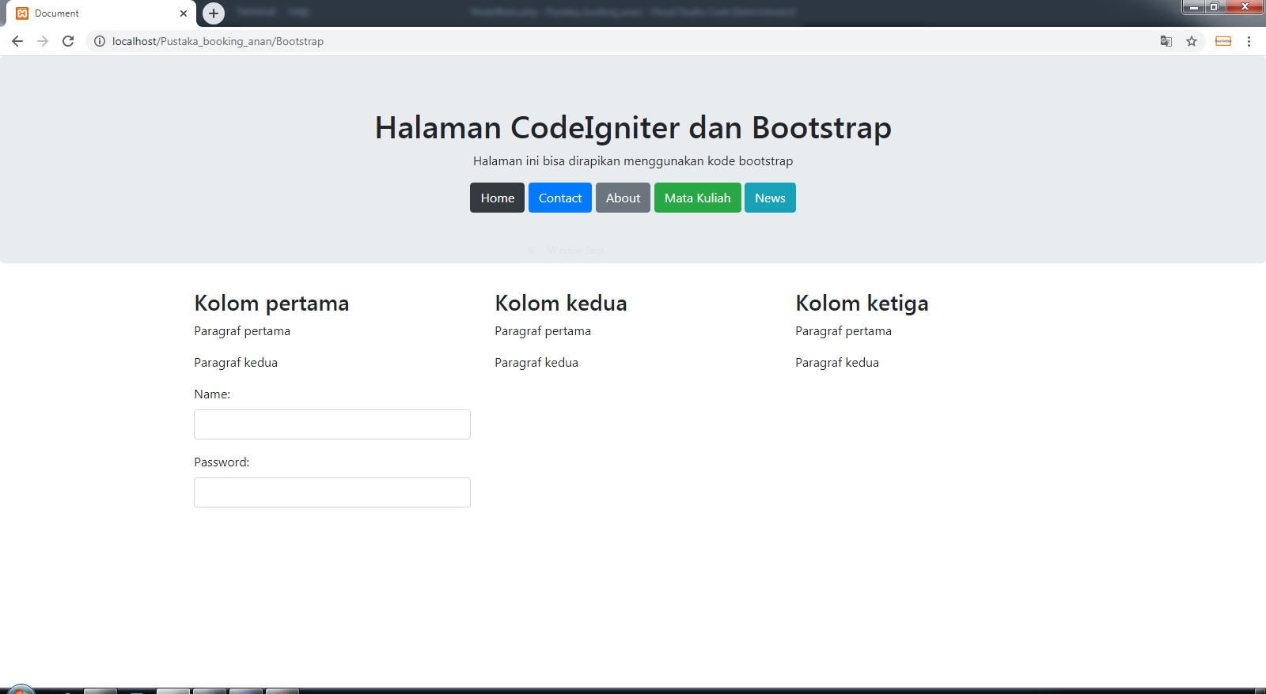

**Database pustaka**

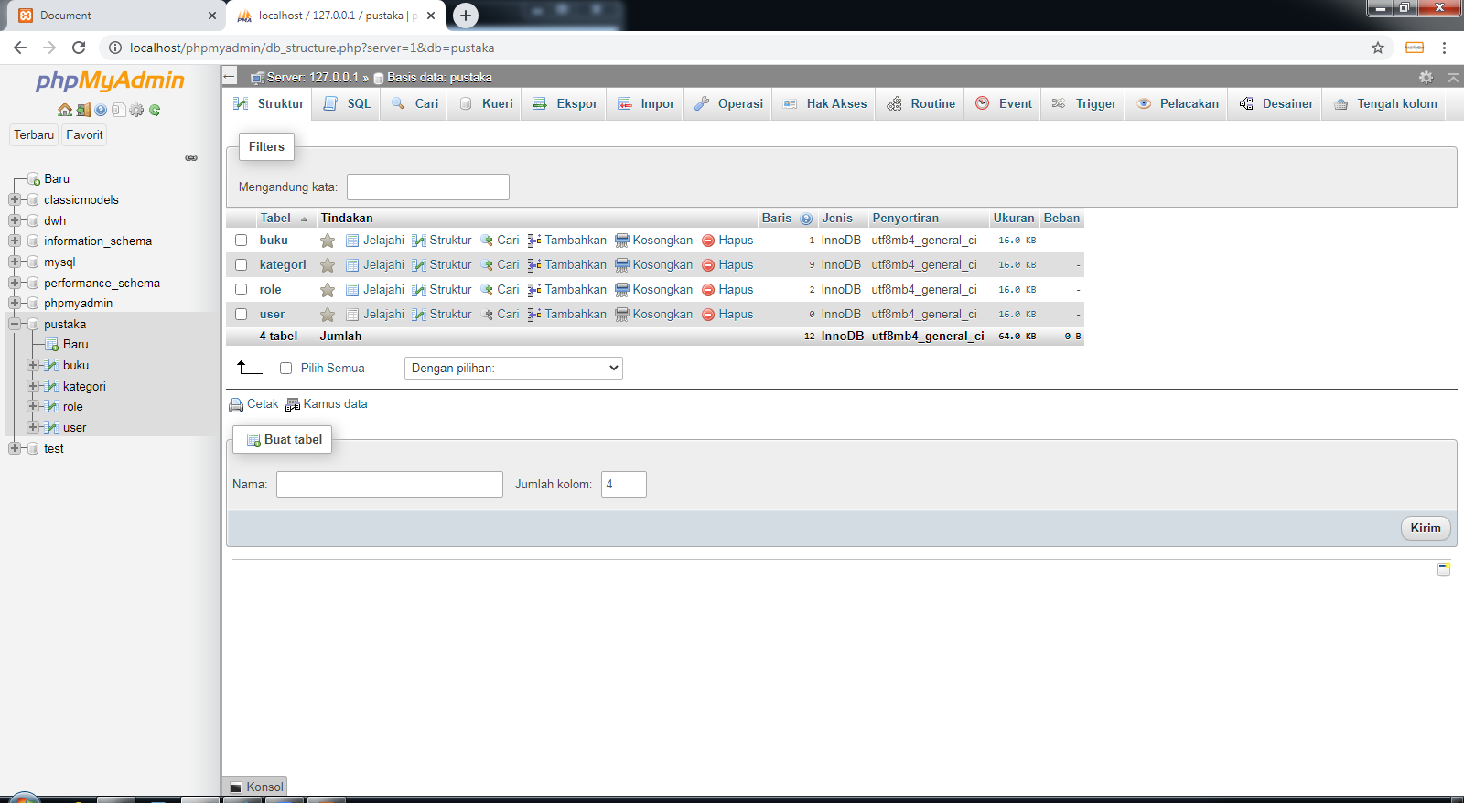

**Table role**

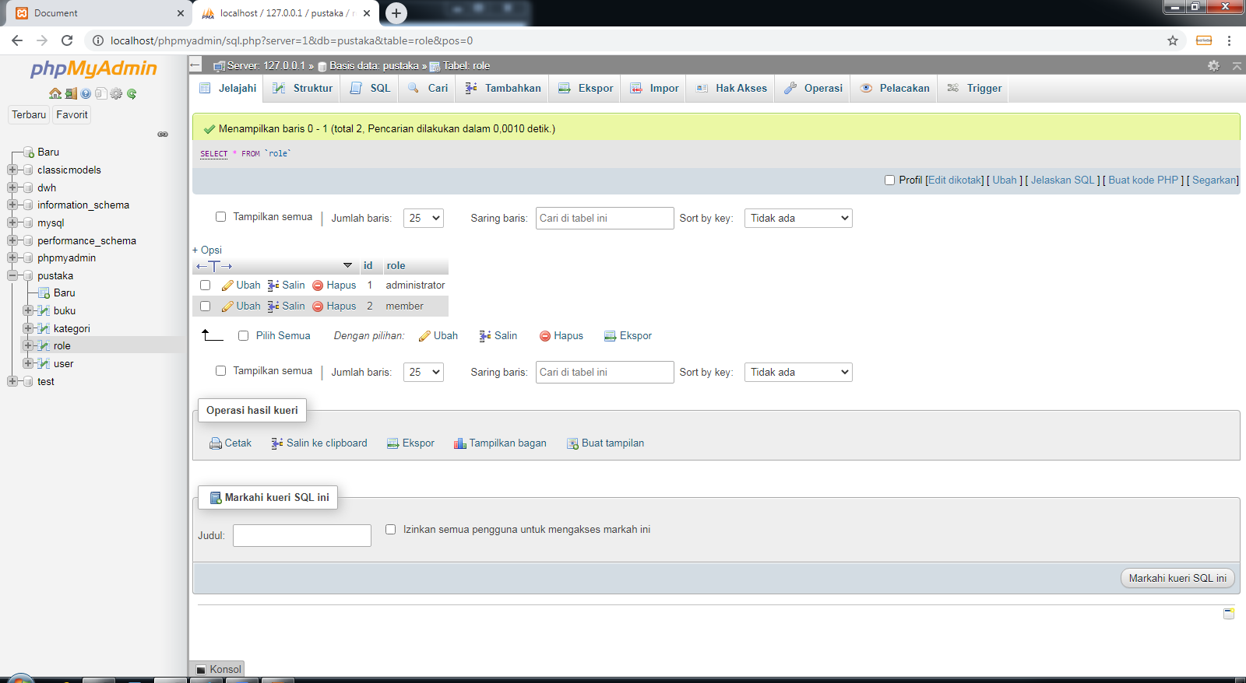

**Table kategori**

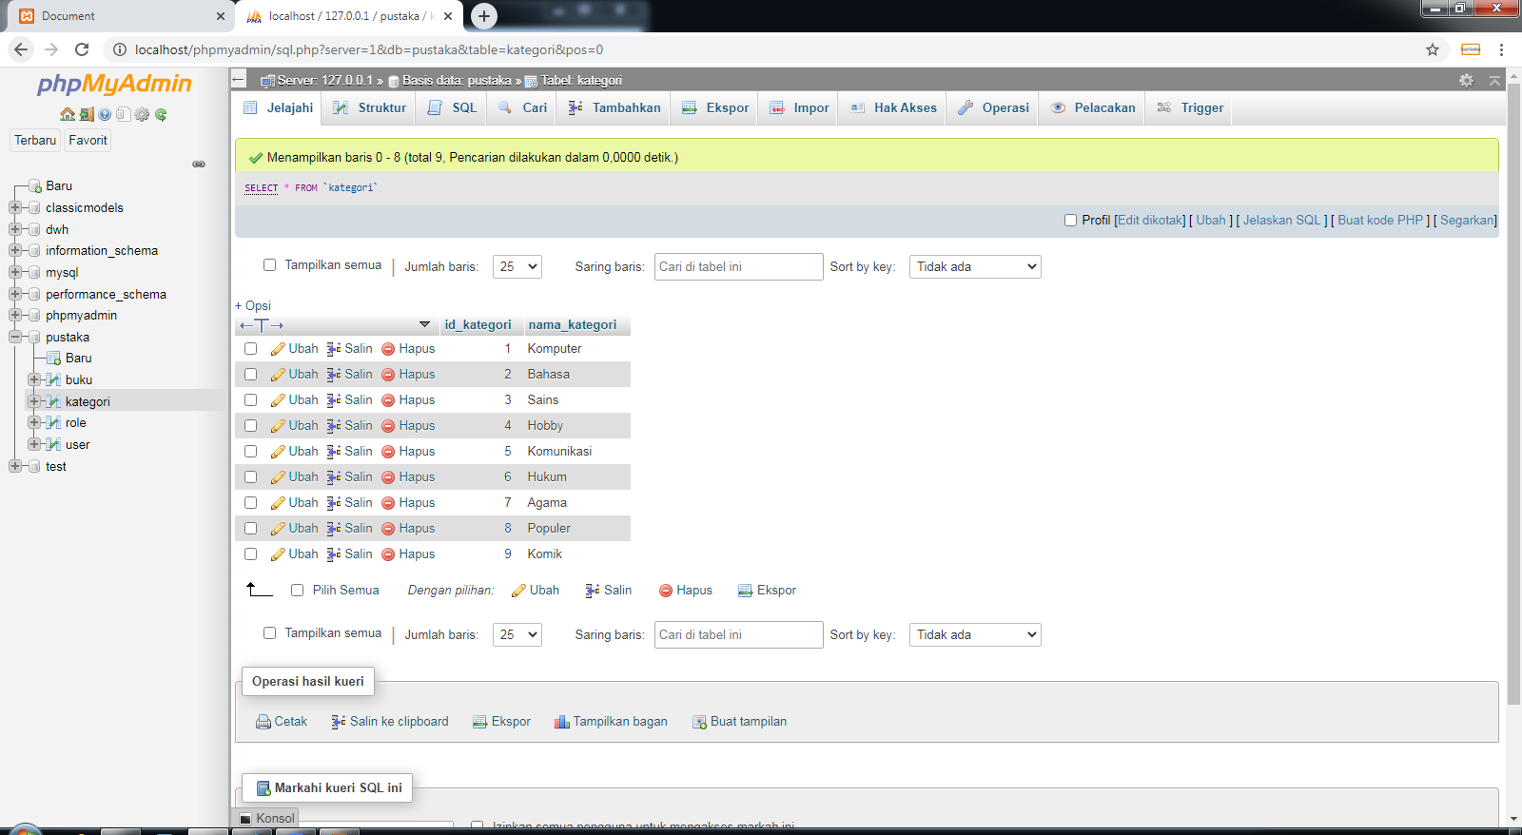

**Table buku**

